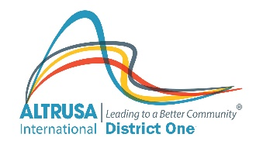 | Altrusa International Inc.  District One  Pre-Visit Survey Form
Club Name | Altrusa International of
Club President
President’s Address
About your club:
Number of active club members
What is your average meeting attendance?
Are your business and program meetings separate?
Do you have separate operating and service project budgets?
Do you have a club Foundation?
How many club members attended the last: |  |  | Workshop?
 |  |  | Conference?
 |  |  | Convention?
Membership: Recruitment and Retention
How do you handle new member recruitment and member retention?
Do you conduct orientation/re-orientation programs?

If yes, how often?
How can district help you with recruitment and retention?
Publicity / Marketing
Do you have a club newsletter?
Do you have a club yearbook?
Is your club website up to date (officers, meeting nights, contact information)?
Do you use Facebook to spread current club event information?
Are you following Altrusa District One on Facebook?
Club Activity Report (CAR)
Did you submit a CAR for last year?
Did your club submit entries for the following awards? |  | Mamie L. Bass Service Award
 |  | Letha H. Brown Literacy Award
 |  | Dr. Nina Fay Calhoun International Relations Award
 |  | Newsletter
 |  | Gabrielle Crepeau Award

Strategic Plan
Do you have a Strategic Plan?
If yes, when was it last reviewed?
If no, do you want assistance from District?
Do you use the Strategic Plan when planning yearly activities?
Relationship with District
Do your members attend Workshop/Conference?
If no, what would encourage them to attend?
Relationship with International
Do you support the International Foundation?
If yes, how?
- Budget
- Individual Gifts
- Memorials
- Other
Have you applied for / received an International Grant?
If no, can we help with that?
Summary:
What are the most pressing needs of your club?

What topics of discussion would be most beneficial for your members?

How can district be of help to your club?

Report Completed by:
Date:

Complete and email to District Visitor at least 1 week before the club visit.

