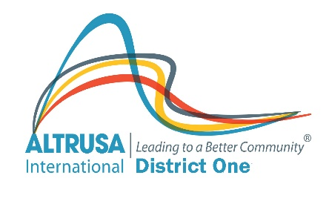 | Altrusa International, Inc.  District One  Feedback on District Visitor
Club Name | Altrusa International of
Club President
Date of Visit
District Visitor Name
District Visitor Office
Preparation:
Did you request any specific additional information from the District Representative? If yes, was it delivered?

Feedback
Describe the District Representative’s participation at the Board meeting.

Describe the District Representative’s participation at the Club meeting.

Summary:
Do you have any suggestions for making the District Visit more effective?

Are there members of your club who should be considered for District Leadership positions?
Who and what position?

Is there anything else District can help you with?

Report Completed by:

Date:

Complete and email to District Governor within 1 week of your club visit.

