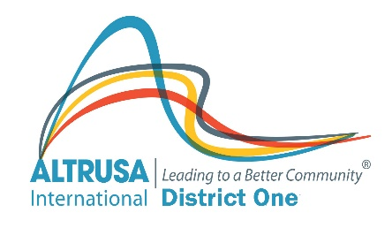 |  | Altrusa International Inc.  District One  Club Visit Summary  This information will be used solely by  District Officers as a guide to help local clubs.
Altrusa International of |  |  |  |  | District Officer:
President: |  |  |  |  | Position:
Date of Club Visit: |  |  |  |  | Date Report Completed:
Board Meeting
Regularly Scheduled? Y N | Special? Y N |  |  | Agenda for All? Y N |  |  | Financial Report for All? Y N
Number of Board Members: |  |  |  | Number of Board Members Attending:
Brief description of business covered:

Club Meeting
Regularly Scheduled? Y N | Special? Y N |  |  | Agenda for All? Y N |  |  | Financial Report for All? Y N
Number of Club Members: |  |  |  | Number of Club Members Attending:
Brief description of meeting content:

Was meeting efficient? Y N |  |  | Was there broad participation? Y N |  |  | Were committee reports given? Y N

Impressions
Identify Club Strengths:

Describe Club Weaknesses:

General Observations:

Recommendations Made to Club:

Special Concerns or Questions by This Club

Officer Recommendations to Board Regarding This Club:

Potential District Leaders – none at this time
Name: | Role:
Name: | Role:
Name: | Role:

Complete and email to Club President (with copy to the Governor) within 1 week of the club visit.

