Information Scavenger Hunt

Presented to District One April 8, 2021 via Zoom Training Session

Tonight we will talk a little bit about the resources provided by Altrusa International to help us be better Altrusans. Knowledge is the ladder to greater achievement. As we grow in knowledge about Altrusa, its rich history, its structure and how it functions, the greater success we will have in spreading the good news of Altrusa in our communities. The more we know about Altrusa, the more excited and prouder we are to be Altrusans. And the excitement will be infectious. We need to be able to talk the talk about Altrusa….which leads us to Gabrielle Crepeau.

Each year District One honors the memory of Gabrielle Crepeau by awarding at spring conference the Gabrielle Crepeau Leadership Award. Gabrielle Crepeau, Gaby, was Governor Elect at the time of her death in December, 2000. Many of us “ole” Govs served on the District Board with Gaby. Gaby NEVER NEVER came to a District One Board meeting without her Encyclopedia, International Bylaws (District and Club) , International policies, and especially her District policies. She may even have had a Point of Order tucked in her bag as well.

She taught us how to use these resources….. She taught us…. Whatever the question…Don’t guess, don’t assume…LOOK IT UP.

So, when Governor Linda asked us to prepare a presentation, we immediately thought about Gaby. In the “ole” days, we didn’t have a website, with all kinds of wonderful information about Altrusa, its history, its structure, how it functions. We had hard copy publications! And we had to buy them. Now all these resources are readily available, wherever we are. We can even use our phones!

Expectations What do we want to accomplish?
The words that come to my mind for the expectations for this evening are REFRESH Refresh our knowledge of Altrusa….RENEW Renew our commitment to Altrusa AND LEARN When we learn about Altrusa we grow in service and love of Altrusa .

Member participation and knowledge is significant to the growth of Altrusa. The more knowledge each member has, the greater the impact.
I don’t like to use the word “sell’’ but to sell Altrusa…to get someone interested in Altrusa…You need to know Altrusa and when you know it, you can’t help but love it….You know its mission, its integrity and the good it accomplishes around the world.
So if we do nothing more tonight than stimulate your curiosity in the resources available to you from the International Association, then we have done our job.

The Altrusa International web site is a plethora of materials, information and tool kits for use by Altrusa members. And don’t overlook the District One website. There is good stuff there as well.
The Website address is Altrusa.org and the District website address is districtone.altrusa.org
The resources we will use this evening are:
- The Altrusa Tradition
- Club President’s Handbook
- Altrusa International Encyclopedia
- Point of Order
- International Bylaws
- District Bylaws
- Club Bylaws
- International Policies
- District Policies and Club Policies
These resources can all be found on the Altrusa International Web site. Altrusa.org This is a small portion of what is available to Altrusans on the web site but significant in their nature and importance.

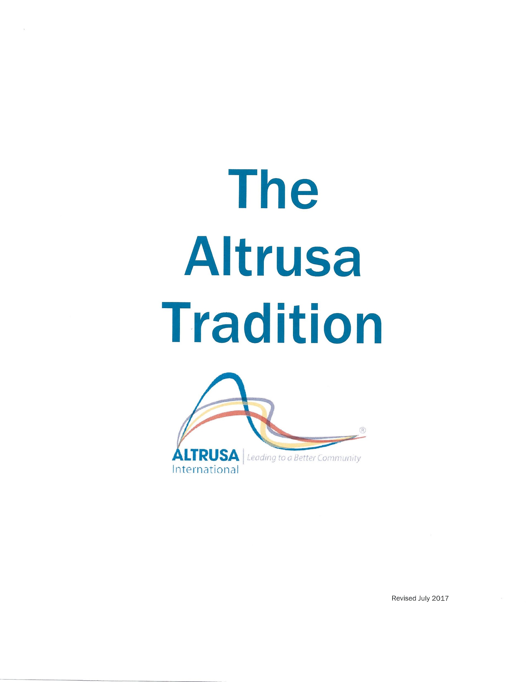
The Altrusa Tradition is a very interesting publication, to many like me it is fascinating. It documents the history of Altrusa International, Inc. You can read it on line or you it can download a copy from the website. It’s free. You will find it at Altrusa.org under the membership tab.
- Altrusa.org
  - Member login
Userid Altrusan
Password MamieLethaNina1917
International President Verona Bordok (1983–1985) asked Hazel P. Williams and Lucille E. Hecht, to co-author the Altrusa Tradition and share what they personally observed of Altrusa’s history, so that “We (you and I) can build upon and carry forward the important truths of our heritage.”

Hazel P. Williams became a member of the Altrusa Club of Indianapolis, Indiana, in 1919. She was right there with Mamie L. Bass. She was elected to various national positions, and in 1946 became executive director of the association—and she held that position until her retirement in 1967. Hazel shared her knowledge of the history of Altrusa with Lucille Hecht, who was the editor of the International Altrusan from 1945 to 1979.

The very first edition of The Altrusa Tradition was distributed at the 1985 International Convention in Boston, Massachusetts…District One… It has been revised several times since 1985. A revised edition was prepared for the celebration of Altrusa’s 75th anniversary in April 1992, and there was an extensive update for the celebration of Altrusa’s 100th Birthday in 2017.

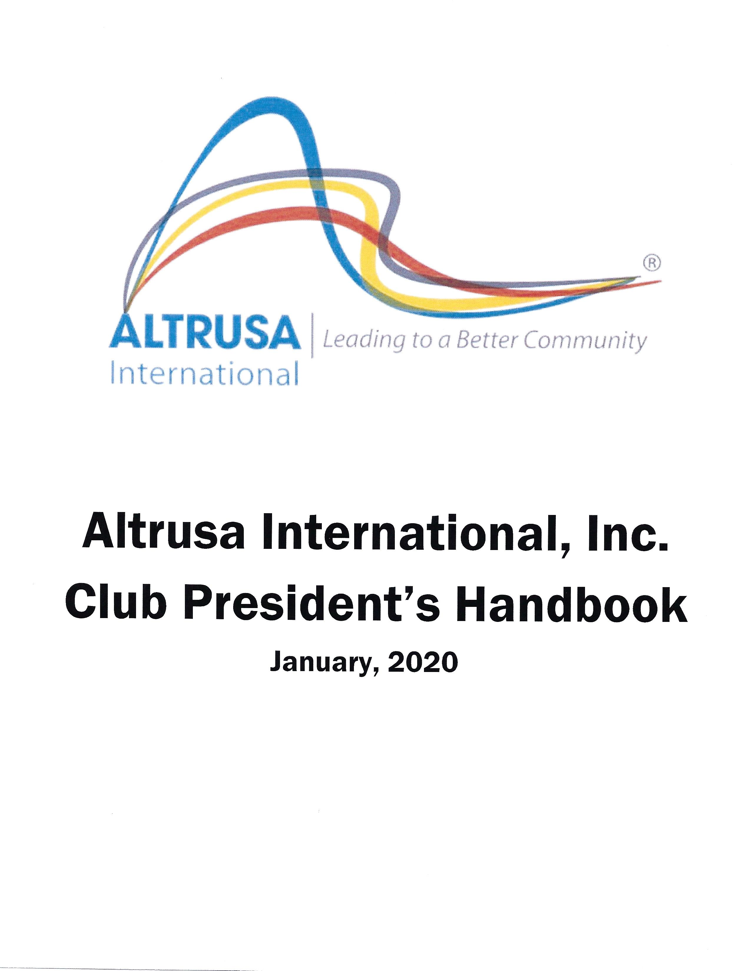
The Club President’s Handbook is an in depth guide to assist club presidents in their leadership role. However, it also has good general information that is of value for other officers, committee chairs, and members.
Past Governor Bobbi Tundermann (serving from 2000-2002) played an instrumental role in putting the first Club President’s Handbook together. It was a compilation of the Accents that were mailed to Presidents each year.
A good example of its general information is the Club Liability Insurance.
I randomly opened the handbook to page 34 and the Heading was Club Liability Insurance. As you may know, the International Association has an insurance policy that covers all Altrusa Clubs when performing service projects or conducting a fundraisers. This is important information for all members. The Handbook has questions and answers that are very helpful.
However, like any insurance policy, there are limitations. So, always contact the insurance agent, Cook and Kocher, to ensure coverage.
You can email our contact Michelle Wolf at michellew@cookandkocher.com

This topic is also covered in the Altrusa International Encyclopedia, which segues into one of the main topics we will address tonight.

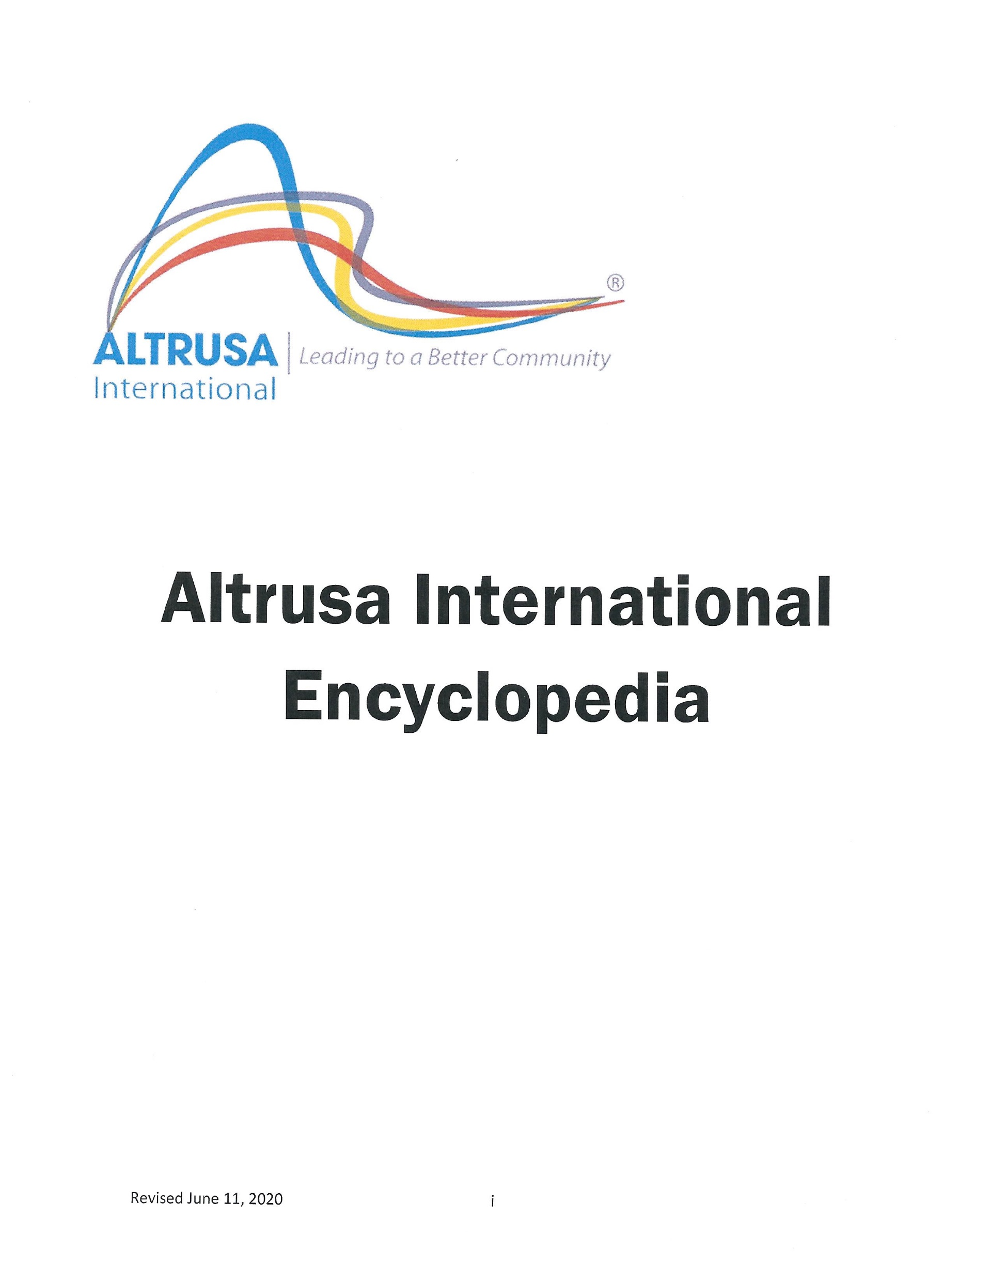Altrusa International Encyclopedia is one of the most important resources for ALL Altrusans and is available on the website under the membership tab.
The ALTRUSA ENCYCLOPEDIA is your Altrusa resource library. It is an easy to use, comprehensive source that has all the information you as a member need in order to understand the Altrusa organization. The Encyclopedia is a living document and is updated as needed.
It has EVERYTHING you ever needed to know about Altrusa. Everything you ever wanted to know about Altrusa and more….. Obviously, this is why it has its name.

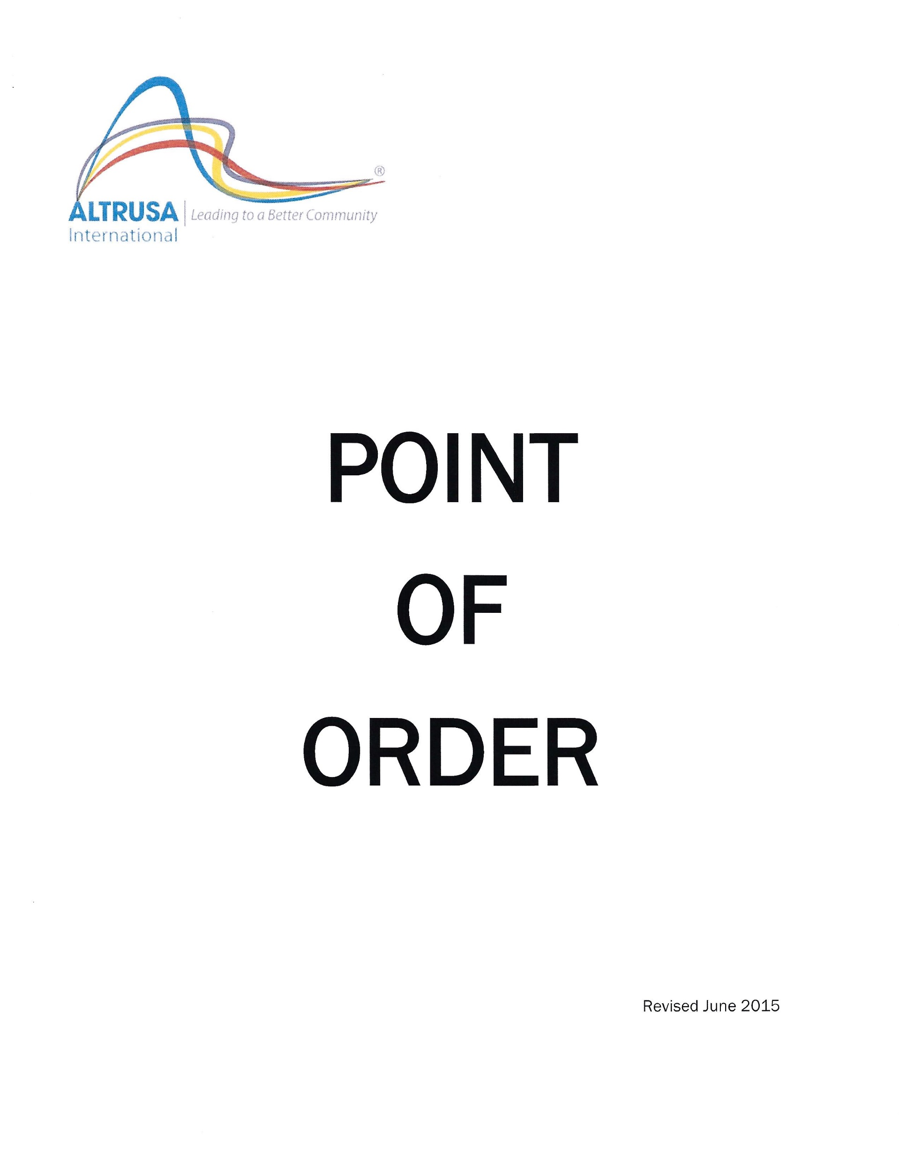The Point of Order is a simplified guide to parliamentary procedure i.e. Robert’s Rules. It was specifically designed for Altrusa International. It is conveniently placed under the leadership tab on the International website.
Every member should have BASIC knowledge of how a business meeting should be run. Examples: Minutes need to be accepted by vote and Treasurer Reports and Committee Reports are placed on file; how to make a motion; how to end discussion. etc

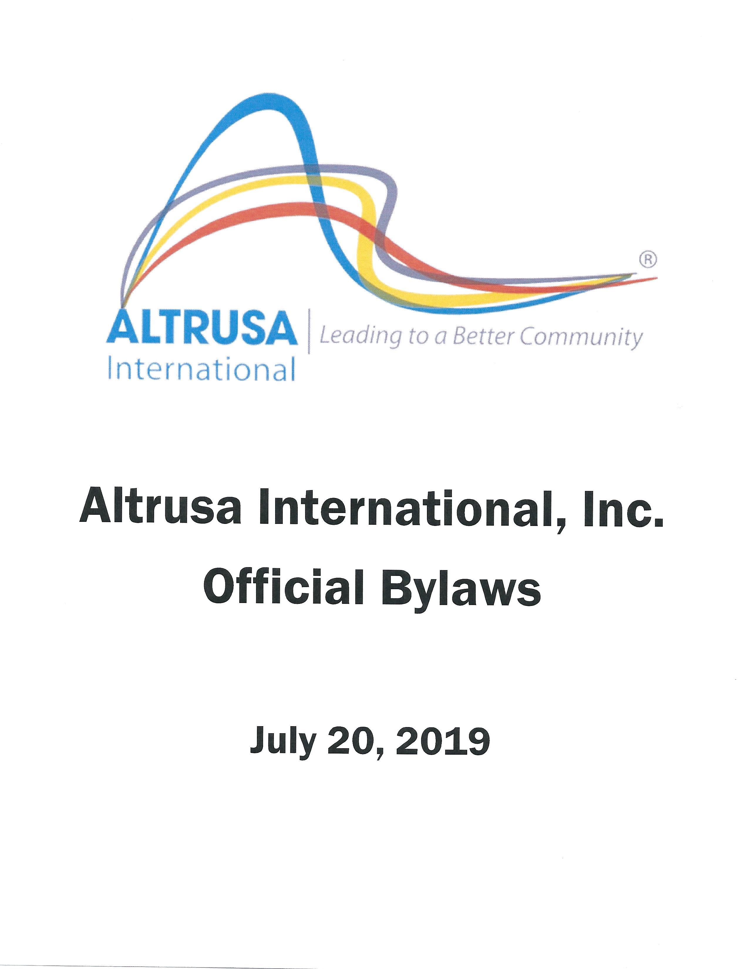The Altrusa International Bylaws, which include the District and Club bylaws, are the rules and guidelines that describe the purpose of Altrusa International and explain in detail the manner in which the organization functions. It provides the rights and privileges of members and the duties of officers, chairpersons, and committees at the club, district and international levels.
Every Club member should have a copy of the International bylaws and a copy of the Club Bylaws. Each member should have a good general knowledge of the Club Bylaws….from International and those that the club itself has established. Not all clubs have a separate set of Club Bylaws. It would behoove you to find out if your club has a separate set of bylaws or whether the club just uses what International has established.
The Bylaws can be found under the Governance tab on the Altrusa website.

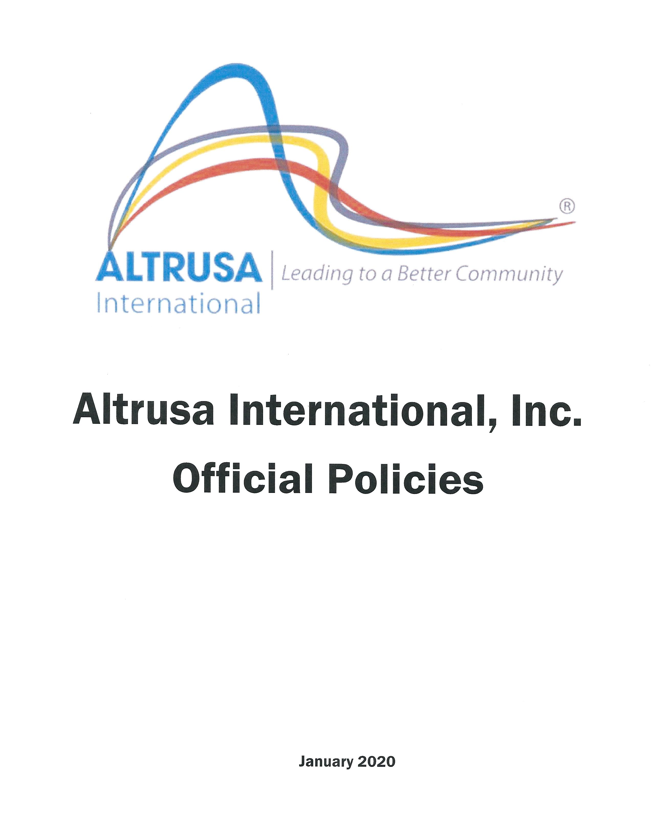Altrusa International Official Policies clarify and maintain consistency in the operations and processes of the Altrusa International organization, and they include the District Policies and Club Policies. They can be found at Altrusa.org under Governance
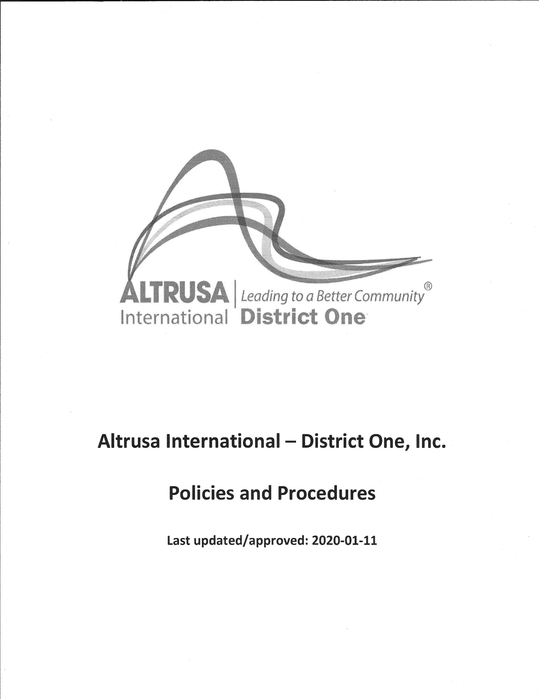
Here again, we know that the District has policies and they can be found on the District web site. www.districtone.altrusa.org
Some clubs have a set of club policies, some don’t.

The following questions are designed to help you find the right answer when you need it. Where to look!

Grab a piece of paper and pen and make a list of 1 to 20

Questions:

1.
2.
3.

Information Scavenger Hunt
Q# | Question | Answer
1 | Who can vote at the District One Conference? | - District Bylaws p. 26  - Article VI Meeting of Members  - Section 7 Members entitled to vote  - Club Delegates, Duly elected District One Board members, Past Governors, Past International Presidents (Life Members) if applicable
2 | How many members of the same Club can be elected to serve on the District Board per biennium? | ANSWER = TWO (2)  - District Bylaws p. 29 Article XI Officers  - Section 1 Elected Officers (d)  - District One Policies Page 10, #17.1  (districtone.altrusa.org Resources Tab)
3 | Who can vote at an International Convention? | - International Bylaws, p.13  - Article VI Meeting of Members  - Section 6 Members Entitled to Vote  - International Board of Directors, Past International Presidents, District Governors, Past Governors and duly elected delegates from Clubs
4 | Can someone be elected to serve on the District One Board without having served as a Club President? | - District Bylaws, p. 29  - Article XI, Section 1 Elected Officers  - (i) p.30  - (ii) To be eligible for election to any District Office EXCEPT Treasurer, a person must have completed a term of Club President. To Be District Treasurer, a person must have served a complete term of Club President OR Treasurer.
5 | Find the territorial limits of District One. | - Encyclopedia p. 27  - Geographical Boundaries  - Bermuda, all the New England States, and from Ontario east, including Sudbury, Quebec, New Brunswick, Nova Scotia and Prince Edward Island
6 | What is the eligibility to be elected to serve as District One Governor-Elect? | - District Bylaws, p. 29  - Article XI Officers,  - Section 1 Elected Officers  - Sub-section (i) p. 30 The candidate must have previously completed a full term as a member of the District Board.
7 | What is the eligibility to be elected to serve as Club President? | - Club Bylaws, p.40  - Article XI Officers, Section 3 Qualifications  - To be eligible to serve as Club President, the candidate must have served one full year as a member of the Club Board of Directors in the past five (5) years.
8 | Can a person second a Motion even if the person is not in favor of the Motion? | - Point of Order,  - p. 7  - Taking Action  - Making a Motion  - P. 8 Step 2  - Seconding a Motion does not imply a member’s support
9 | What is the definition of a majority vote? | - Point of Order,  - p. 14 The Vote  - Majority Vote – the majority of votes cast
10 | What is the formula for the number of delegates a club is allowed in order to vote at International Convention? | - International Bylaws, p. 12  - Article V Delegates to Convention  - Section 1 Number of Delegates Authorized  - 1 – 15 = 1 Delegate 1 Alternate  - 16 – 30 = 2 Delegates 2 Alternates  - 31 – 45 = 3 Delegates 3 Alternates  - 46 – 60 = 4 Delegates 4 Alternates  - 61 or more Maximum 5 Delegates and 5 Alternates

Q# | Question | - Answer
11 | Who can be elected to the International Board of Directors? (What is the eligibility?) | - International Bylaws p. 17  - Article XI Officers and Directors  - Section 1 Elected Officers and Directors  - (f) To be Eligible (p. 18)  - Active member in good standing  - Must have served full term as District Governor
12 | Can a member take a leave of absence from your Club? | - Encyclopedia p. 34 (tells you where to look)  - Club Bylaws p. 37  - Article VI, Duration of Membership  - Section 5 (page 38) Leave of Absence  - Member may take up to one year leave of absence, but is not exempt from payment of dues during that time.
13 | Find out if a club is covered under Altrusa International’s Liability Insurance Policy. | - Encyclopedia p. 32  A General Liability and Umbrella Policy is provided to Altrusa International, The Altrusa Foundation, all Districts, all Clubs, and all ASTRA Clubs in good standing. The premium cost is included in member dues.  - Club President’s Handbook p. 34-36  - Questions and Answers
14 | When does the election of Club Officers take place? | - Club Bylaws p. 42  - Article XIII Election of Officers and Directors  - Section 1 Election  - Regular Business meeting in March
15 | How are International dues determined? | - Altrusa International Bylaws p. 21  - Article XVIII Dues and Fees  - Section 1 Dues  - Established by the International Board of Directors and approved by the delegate body at International Convention

Q# | Question | ANSWER
16 | What Motion can be made to end debate/discussion? | - Point of Order, p. 9 Limiting Debate  - If a member feels that a motion has been sufficiently discussed, the member may “move the previous question or call the question”. This action requires a second and a 2/3 vote. If it passes, the original motion is immediately voted on.
17 | Find the Principles of Altrusa written by Mamie L. Bass | - Altrusa Tradition p.32-33  - There are 12 Principles of Altrusa  - Written and adopted 1921 (Dayton, Ohio)  - Altrusa International Encyclopedia p. 12
18 | What is the name of the official Publication of Altrusa? | - Encyclopedia p.34  - International Altrusan - all members (1935)  - (Original name National Altrusa Bulletin 1922)  - Altrusa Compass - (Electronic) all members  - Gavel - Governors  - Altrusa Accent - Presidents
19 | What is the minimum number of club members required to transact business? | - Point of Order p. 4 Meetings/Quorums  - Club Bylaws p. 38  - Article VII, Meetings Section 3 Annual  - 1/3 of the membership shall constitute a quorum
20 | Who are the elected Officers of the International Association? | - International Bylaws Article XI  - Officers and Directors  - International President  - President Elect  - Vice President  - Treasurer  - Four (4) Directors

